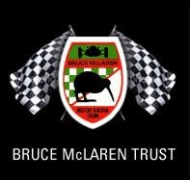
Bruce McLaren Trust,
Hampton Downs Motorsport Park, Industrial Unit 3
20 Hampton Downs Road, R D 2 Te Kauwhata 3782, New Zealand
david@bruce-mclaren.com Ph 09 280 6586

Mail Order Form Date

Name ……………………………………………..

Address…………………………………………….

……………………………………………………. Email …………………………..

……………………………………………………. Phone …………………….

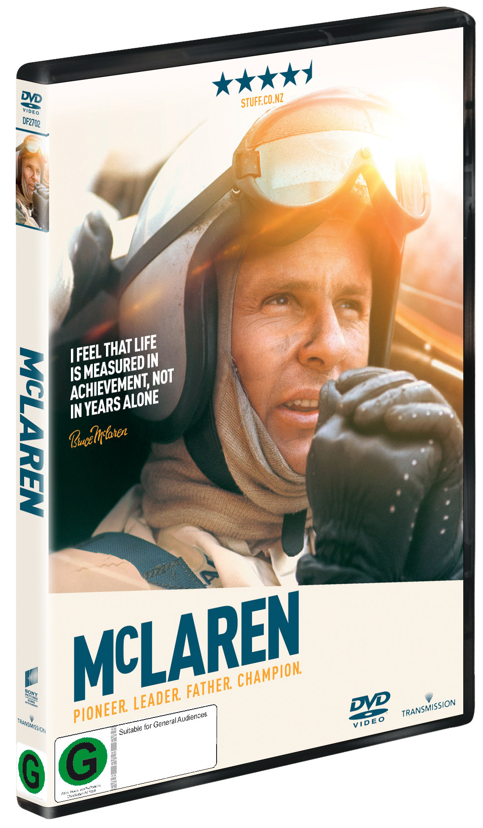
McLaren
Pioneer. Leader.
Father.
Champion.

McLAREN - Now available to add to your movie collection in DVD format.

The documentary directed by Roger Donaldson, is an amazing true story of dream, believe and achieve.

Critic Reviews
“McLaren stands as more a celebration than sombre eulogy … and should hold differing types of appeal to various generations.”
– New Zealand Herald
“Taking a leaf out of Asif Kapadia's award-winning documentary Senna (2010), Donaldson offers a comprehensive account of the highs and lows in the man's short, yet fruitful career.”
– HeyUGuys
“McLaren is a fine documentary made by Ballarat-born NZ filmmaker Roger Donaldson.”
– The Australian

.

Please NOTE this is for New Zealand region only.

Payment: Cheque, Visa, Mastercard, Cash
Visa/Mastercard No:

Expiry date
Signature …………………………………….

McLAREN DVD ……………… @ $28.00 ……………….

Plus NZ post $5.50

TOTAL ……………

